A

**MAJOR PROJECT ON**

**“Food Ordering System”**

**Submitted To**



**Rajiv Gandhi Proudyogiki VishWAvidyalaya Bhopal (M.P.)**

**In Partial Fulfillment of the Degree of**

**Bachelor of TECHNOLOGY**

**in**

**COMPUTER SCIENCE & ENGINeERING**

**Submitted By-**

**Binu Kumari Ray**

**0939CS171002**

**8TH SEM 4th year**

**Under the Guidance of**

**Prof. Naveen Gupta (HOD)**

**DEPARTMENT OF COMPUTER SCIENCE & ENGINEERING**

MALWA INSTITUTE OF TECHNOLOGY AND MANAGEMENT, GWALIOR

DEPARTMENT OF COMPUTER SCIENCE & ENGINEERING



**CERTIFICATE**

This is to certify that the Project entitled **“FOOD ORDERING SYSTEM”** is the record of bonafide work done by **BINU KUMARI RAY** under my guidance for the partial fulfillment of the requirements for the award of the degree of “**Bachelor of Technology.”**

To the best of my knowledge, this project is an original work and has not been submitted anywhere for the award of any degree or diploma.

**Project Guide**

**Naveen gupta**

**HOD, CSE**

**Dr. Dinesh Swarnakar**

**Principal**

MALWA INSTITUTE OF TECHNOLOGY AND MANAGEMENT, GWALIOR



**GWALIOR (M.P.)**



**DECLARATION**

I am students of Bachelor of Technology in Computer Science & Engineering VIII semester, hereby declare that the dissertation entitled **“Food Ordering System”** which is being submitted to Department of Computer Science & Engineering in **MALWA INSTITUTE OF TECHNOLOGY & MANAGEMENT**, Gwalior is my authentic work carried out in VIII semester.

I declare that my work has not been submitted in part or in full to any other university or institution for the award of any degree or diploma.

**Binu Kumari Ray**

**0939CS171002**

**VIIITH SEM**

**FINAL YEAR**

**Date: 20/06/2021**

MALWA INSTITUTE OF TECHNOLOGY AND MANAGEMENT, GWALIOR

**ACKNOWLEDGEMENT**

Before presenting the project report I hereby place my acknowledgment towards those without whom the project was not possible. I am deeply indebted to **Naveen Gupta** forgiving me the opportunity to work on this project. It is the matter of immense pleasure to acknowledge my obligation to my guide for his valuable guidance, encouragement, general co-operation, expert comments, generous hospitality and guidance extended towards me which has been a great source of inspiration to me throughout the course of the project. He has spent his valuable time with me and made me feel the real zest of project work.

I would like to express my gratitude and heartily thanks to **Dr. Bushra Malik,** Director,**Dr. Dinesh Swarnakar,** Principal for their continuous moral support, motivation and encouragement to complete the work.

I would like to express my sincere thanks to **Neha Gupta**, **all faculty and staff members** of Department of Computer Science &Engineering for continuous support and providing departmental facilities needed for my project. I also express special thanks for his help on debugging the project.

I would also like to thank my all the friends for providing supportive environment in completing the work, who helped me for efficient performance in the entire project work.

Iare very thankful to my parents who believe in my capabilities and have always encouraged and supported us in my difficult times of life.

I thank all those who are associated with me in completing the project who formed the stepping stone in the project.

**Project Title**

**“Food Ordering System”**

**Technology:-** C Desktop (Functions , Switch Case , File Handling )

**Language:-**    C Programming Language

**Content**

**Topics:**

1.Introduction

2.Purpose

3.Software Hardware Requirement

4.Code Optimization

5.Output

6.Conclusion

7.Reference

**Introduction**

An online food ordering system can be defined as software that allows restaurant businesses to accept and manage orders placed over the internet. ... First is a website or mobile app for hungry customers to view the restaurant's dishes and place an online order.

Ordering systems are the "mechanical" part of inventory management. They're the programs that take our forecasts, actual orders, safety stock, and, and order quantities, and turn them into purchase orders or production orders. ... The real difference between Push Systems and Pull Systems.

The online food ordering system is one of the latest services most fast food restaurants in the western world are adopting. With this method, food is ordered online and delivered to the customer. This is made possible through the use of electronic payment system. Customers pay with their credit cards, although credit card customers can be served even before they make payment either through cash. So, the system designed in this project will enable customers go online and place order for their food. Due to the great increase in the awareness of internet and the technologies associated with it, several opportunities are coming up on the web. So many businesses and companies now venture into their business with ease because of the internet. One of such business that the internet introduced is an online food ordering system. In today’s age of fast food and take out, many restaurants have chosen to focus on quick preparation and speedy delivery of orders rather than offering a rich dining experience.

**Purpose**

With the improvement of technology, online food ordering systems are becoming a popular topic. That's because they are serving the ever increasing demand for convince. The main purpose of an online ordering system is to provide customers for a way to place an order at a restaurant over the internet.

With a website or mobile app, customers can easily browse all the dishes the restaurant has available, customize dishes to their requirements and place an order. It can also save their favourite orders allowing them to easily re-order that in the future.

From the restaurants perspective, they no longer spend time taking the customers order, stop worrying about communication errors and streamline their order management workflow.

**Software and Hardware requirements**

**SOFTWARE REQUIREMENTS SPECIFICATION**

**Operating System** : Windows->10

**Programming Language** : C

**User Interface** : Console Application

**Database** : File Handling

**HARDWARE REQUIREMENTS SPECIFICATION**

**Processor :**Intel Core

**RAM :** Minimum of 1GB RAM

**Memory :** 500 MB or higher

**Code Optimization**

//---------------------------------------------------------------Food Ordering System In C language------------------------------------------------------------------------------------

#include<stdio.h>

#include<conio.h>

#include<string.h>

#include<stdlib.h>

//-----------------------prototypes of functions---------------------------------------------------

void login();

void home();

void veg();

void Nonveg();

void drinks();

void Breakfast();

void orderConfirm();

void addSomthing();

//------------------------main function-----------------------------------------------------------

void main()

{

FILE *fp;

fp=fopen("login.txt","r");

char username[20],userpassword[20],un[20],up[20];

fscanf(fp,"%s%s",username,userpassword);

printf("Enter The User Name:\n");

gets(un);

printf("Enter The Password:\n");

gets(up);

if((strcmp(username,un)==0)&&(strcmp(userpassword,up)==0))

{

// printf("Login Successfully\n");

printf("Welcome--->%s<---\n",un);

home();

}

else

{

printf("---------------------------------------------------------------------------------\n");

printf("Please Enter currect User Id And Password \n");

printf("---------------------------------------------------------------------------------\n");

login();

}

getch();

}

//------------------------------definations of functions---------------------------------------------

void login()

{

FILE *fp;

fp=fopen("login.txt","r");

char username[20],userpassword[20],un[20],up[20];

fscanf(fp,"%s%s",username,userpassword);

printf("Enter The User Name:\n");

gets(un);

printf("Enter The Password:\n");

gets(up);

if((strcmp(username,un)==0)&&(strcmp(userpassword,up)==0))

{

// printf("Login Successfully\n");

printf("Welcome--->%s<---\n",un);

home();

}

else

{

printf("Please Enter currect User Id And Password \n");

}

}

void home(){

printf("------------------->Welcome To The Restaurant<----------------------------------\n");

printf(" 1 .Veg\n");

printf(" 2 .Non Veg\n");

printf(" 3 .Breakfast\n");

printf(" 4 .Drinks\n");

printf("---------------------------------------------------------------------------------\n");

printf("Enter Your Choice What You Want\n");

int ch;

scanf("%d",&ch);

switch(ch)

{

case 1: printf("You Selected Veg\n");

veg();

break;

case 2:printf("You Selected NonVeg\n");

Nonveg();

break;

case 3:printf("You Selected Breakfast\n");

Breakfast();

break;

case 4:printf("You Selected Drinks\n");

drinks();

break;

default:printf("You Selected Wrong Choice\nPlease Entered Correct Choice\n");

home();

break;

}

}

void veg()

{

printf("---------------------------------------------------------------------------------\n");

printf(" 1 .Paneer Curry\n");

printf(" 2 .Kadai Paneer\n");

printf(" 3 .Daal Fry\n");

printf(" 4 .Sev Bhaji\n");

printf(" 5 .Roti\n");

printf("---------------------------------------------------------------------------------\n");

printf("Select The Option Which You Want:\n");

int ch;

scanf("%d",&ch);

switch(ch)

{

case 1: printf("You Selected Paneer Curry\n");

orderConfirm();

break;

case 2:printf("You Selected Kadai Paneer\n");

orderConfirm();

break;

case 3:printf("You Selected Daal Fry\n");

orderConfirm();

break;

case 4:printf("You Selected Sev Bhaji\n");

orderConfirm();

break;

case 5:printf("You Selected Roti\n");

orderConfirm();

break;

default:printf("You Selected Wrong Choice\nPlease Entered Correct Choice\n");

veg();

break;

}

}

void Nonveg()

{

printf("---------------------------------------------------------------------------------\n");

printf("Select The Option Which You Want\n");

printf(" 1 .Chickan Curry\n");

printf(" 2 .Chickan Mashala\n");

printf(" 3 .Fish curry\n");

printf(" 4 .Fish Fry\n");

printf(" 5 .Roti\n");

printf(" 6 .Chawal\n");

printf("---------------------------------------------------------------------------------\n");

printf("Select The Option Which You Want:\n");

int ch;

scanf("%d",&ch);

switch(ch)

{

case 1: printf("You Selected Chickan Curry\n");

orderConfirm();

break;

case 2:printf("You Selected Chickan Mashala\n");

orderConfirm();

break;

case 3:printf("You Selected Fish curry\n");

orderConfirm();

break;

case 4:printf("You Selected Fish Fry\n");

orderConfirm();

break;

case 5:printf("You Selected Roti\n");

orderConfirm();

break;

case 6:printf("You Selected Chawal\n");

orderConfirm();

break;

default:printf("You Selected Wrong Choice\nPlease Entered Correct Choice\n");

Nonveg();

break;

}

}

void Breakfast()

{

printf("---------------------------------------------------------------------------------\n");

printf("Select The Option Which You Want\n");

printf(" 1 .Poha Sev\n");

printf(" 2 .Poha Sev Jalabi\n");

printf(" 3 .Samosa\n");

printf(" 4 .Cachori\n");

printf("---------------------------------------------------------------------------------\n");

printf("Select The Option Which You Want:\n");

int ch;

scanf("%d",&ch);

switch(ch)

{

case 1: printf("You Selected Poha\n");

orderConfirm();

break;

case 2:printf("You Selected Poha Sev Jalabi\n");

orderConfirm();

break;

case 3:printf("You Selected Samosa\n");

orderConfirm();

break;

case 4:printf("You Selected Cachori\n");

orderConfirm();

break;

default:printf("You Selected Wrong Choice\nPlease Entered Correct Choice\n");

Breakfast();

break;

}

}

void drinks()

{

printf("---------------------------------------------------------------------------------\n");

printf("Select The Option Which You Want\n");

printf(" 1 .Normal Water\n");

printf(" 2 .Child Water\n");

printf(" 3 .Pepsi\n");

printf(" 4 .Juice\n");

printf("---------------------------------------------------------------------------------\n");

printf("Select The Option Which You Want:\n");

int ch;

scanf("%d",&ch);

switch(ch)

{

case 1: printf("You Selected Normal Water\n");

orderConfirm();

break;

case 2:printf("You Selected Child Water\n");

orderConfirm();

break;

case 3:printf("You Selected Pepsi\n");

orderConfirm();

break;

case 4:printf("You Selected Juice\n");

orderConfirm();

break;

default:printf("You Selected Wrong Choice\nPlease Entered Correct Choice\n");

drinks();

break;

}

}

void orderConfirm()

{

printf("---------------------------------------------------------------------------------\n");

printf("Confirm Your Oder Just Click Please\n");

printf("---------------------------------------------------------------------------------\n");

printf("1.Yes\n");

printf("2.No\n");

int ch;

scanf("%d",&ch);

switch(ch)

{

case 1:printf("Your Order Is Successfull On The Way\n");

addSomthing();

break;

case 2:printf("Sorry! Canceled Your Order\n");

break;

default:printf("You Entered Wrong Choice\nPlease Entered Correct Choice\n");

orderConfirm();

break;

}

}

void addSomthing()

{

printf("---------------------------------------------------------------------------------\n");

printf("Do You Want To Add Somthing Else!\n");

printf("---------------------------------------------------------------------------------\n");

printf("1. Yes\n");

printf("2. No\n");

int ch;

scanf("%d",&ch);

switch(ch)

{

case 1:printf("Iteam Added Successfully \n");

home();

break;

veg();

break;

Nonveg();

break;

drinks();

break;

Breakfast();

break;

case 2:printf("---------------------------------->Visit Again<----------------------------------");

break;

default:printf("You Entered Wrong Choice\nPlease Entered Correct Choice\n");

addSomthing();

break;

}

**Output**

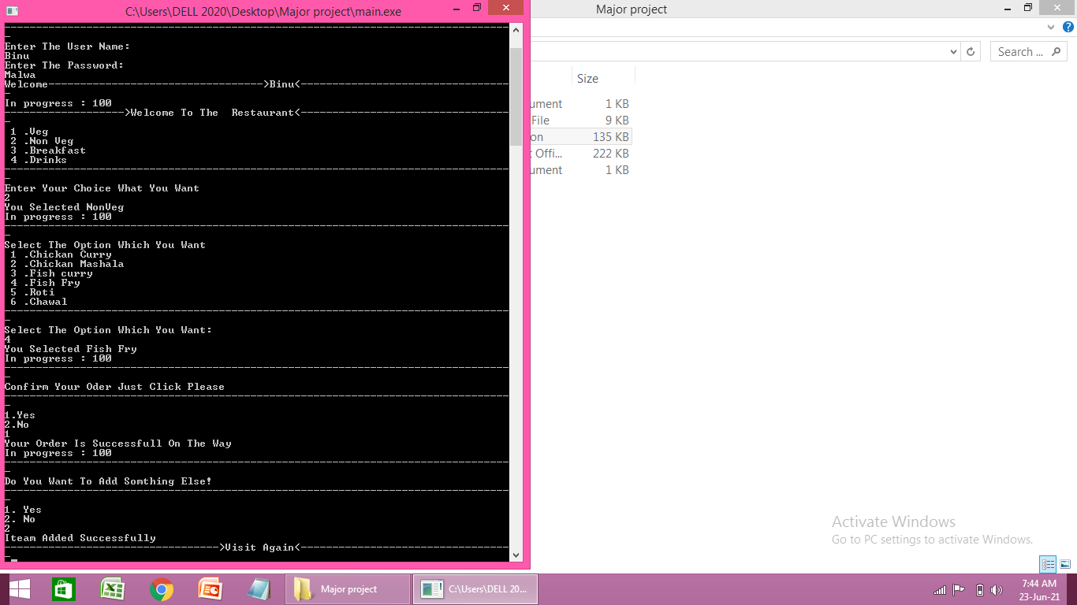

**Conclusion**

#### **Customer Experience:-**

It is a fact, if your customers like your service, they will come back and also recommend you to their world. They will become your best advertisers. So, you need to commit to a service that keeps them coming back

It can be done by making the ordering process convenient for them. Eventually, this “convenience” will pay huge dividends for your restaurant. One thing is certain that people don’t like to order their food over the phone. Everyone wants to place their order without fuss and undoubtedly, asap.

#### **Web Presence:-**

 Managing a restaurant in these times means that you need to have a strategic online representation.

Your business needs to maintain a competent presence at various search engines and social media platforms.

#### **Productivity:-**

Instead of wasting time taking orders over the phone, orders can be received online, and the orders received from the customers directly have matchless accuracy.

**REFERENCES**

**Websites:**

1. W3school.com
2. Javatpoint.com

**Books:**

1.Book->Let uc c